Week 1: Design Pattern and Principles

Exercise 1: Implementing the Singleton Pattern
//.Logger class
public class Logger {
private static Logger instance;
private Logger() {
}
public static Logger getInstance() {
if (instance == null) {
instance = new Logger();
}
return instance;
}
public void log(String message) {
System.out.println("Log: " + message);
}

}
//. SingletonPatternTest class
public class SingletonPatternTest{
public static void main(String[] args) {
Logger logger1 = Logger.getInstance();
Logger logger2 = Logger.getInstance();

logger1.log("This is a log message from logger1.");
logger2.log("This is a log message from logger2.");

System.out.println(logger1.hashCode());
System.out.println(logger2.hashCode());
System.out.println("Are both loggers the same instance? " + (logger1 == logger2));
}
}
Output:
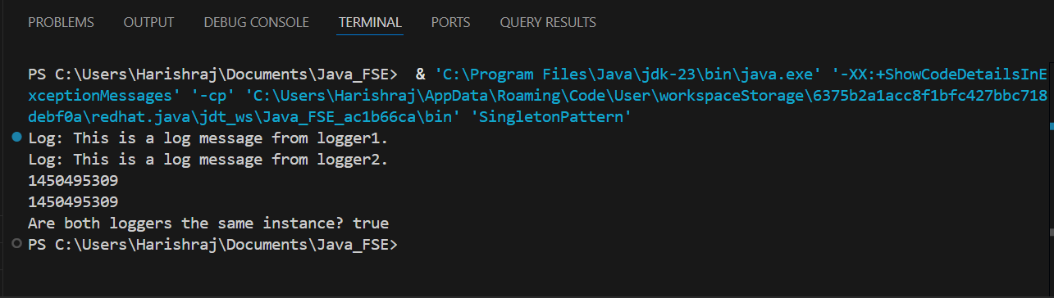

Exercise 2: Implementing the Factory Method Pattern
import java.util.Scanner;

public class FactoryMethodPattern {
public interface Document {
void open();
void close();
}
public static class WordDocument implements Document {
@Override
public void open() {
System.out.println("Opening Word Document.");
}
@Override
public void close() {
System.out.println("Closing Word Document.");
}
}
public static class PdfDocument implements Document {
@Override
public void open() {
System.out.println("Opening PDF Document.");
}
@Override
public void close() {
System.out.println("Closing PDF Document.");
}
}
public static class ExcelDocument implements Document {
@Override
public void open() {
System.out.println("Opening Excel Document.");
}
@Override
public void close() {
System.out.println("Closing Excel Document.");
}
}
public abstract static class DocumentFactory {
public abstract Document createDocument();
}
public static class WordDocumentFactory extends DocumentFactory {
@Override
public Document createDocument() {
return new WordDocument();
}
}
public static class PdfDocumentFactory extends DocumentFactory {
@Override
public Document createDocument() {
return new PdfDocument();
}
}
public static class ExcelDocumentFactory extends DocumentFactory {
@Override
public Document createDocument() {
return new ExcelDocument();
}
}
public static class FactoryMethodTest {
public static void main(String[] args) {
Scanner scanner = new Scanner(System.in);
System.out.println("Enter the type of document to create (Word, PDF, Excel):");
String documentType = scanner.nextLine().trim().toLowerCase();
DocumentFactory factory = null;
switch (documentType) {
case "word":
factory = new WordDocumentFactory();
break;
case "pdf":
factory = new PdfDocumentFactory();
break;
case "excel":
factory = new ExcelDocumentFactory();
break;
default:
System.out.println("Invalid document type.");
System.exit(1);
}
Document document = factory.createDocument();
document.open();
document.close();
scanner.close();
}
}
}
Output:
